Campus Booking System User Guide

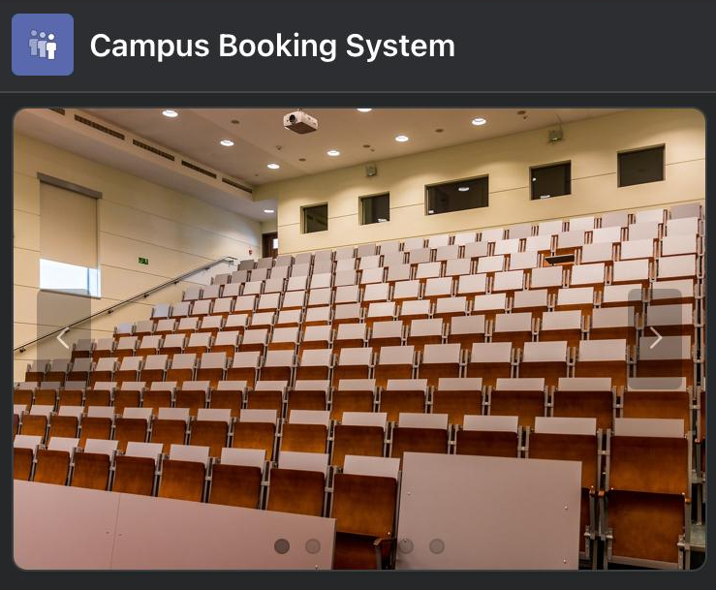

Table of Contents
1. About the application 3
2. Logging onto the application 4
3. Navigating the campus booking system application 6
4. Create booking 10
5. Update bookings 18
6. Previous bookings 20
7. User profile 21
8. Administration home page 24

About the application
The campus booking system allows students and staff to manage their resource booking in one place.
It is built using Oracle application express (APEX) and is a cloud-based application.

Logging onto the application
Access to the application is managed through by campus booking administration team. All students will automatically be set up with an account when registered to attend the college. Staff will be provided with log on details as part of their induction process.
If individuals that are not automatically registered on the system require access to the campus booking application, they can request access which will be reviewed and approved by the administration team.
Step | Instructions
1 | Open link to application on web browser using by clicking here.
2 | Log in using your log in details or select ‘continue with google’. 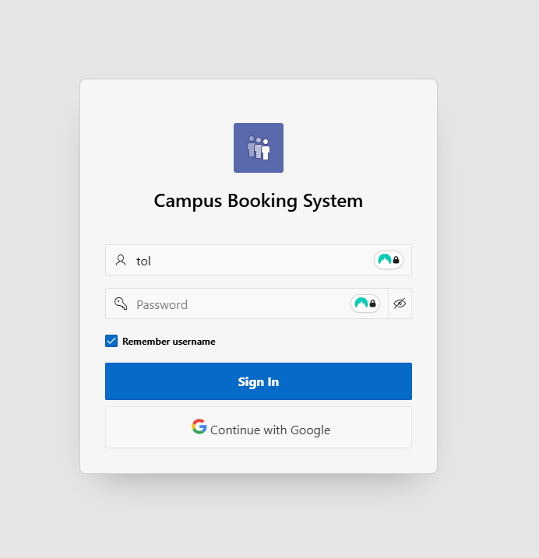  If you are a new user and select ‘continue with google’ please continue to step 3, otherwise continue to step 4.
3 | If you are a new user and select ‘continue with google’ you will be asked to log into your google workspace account and then asked to complete the New User form on the Campus Booking System. 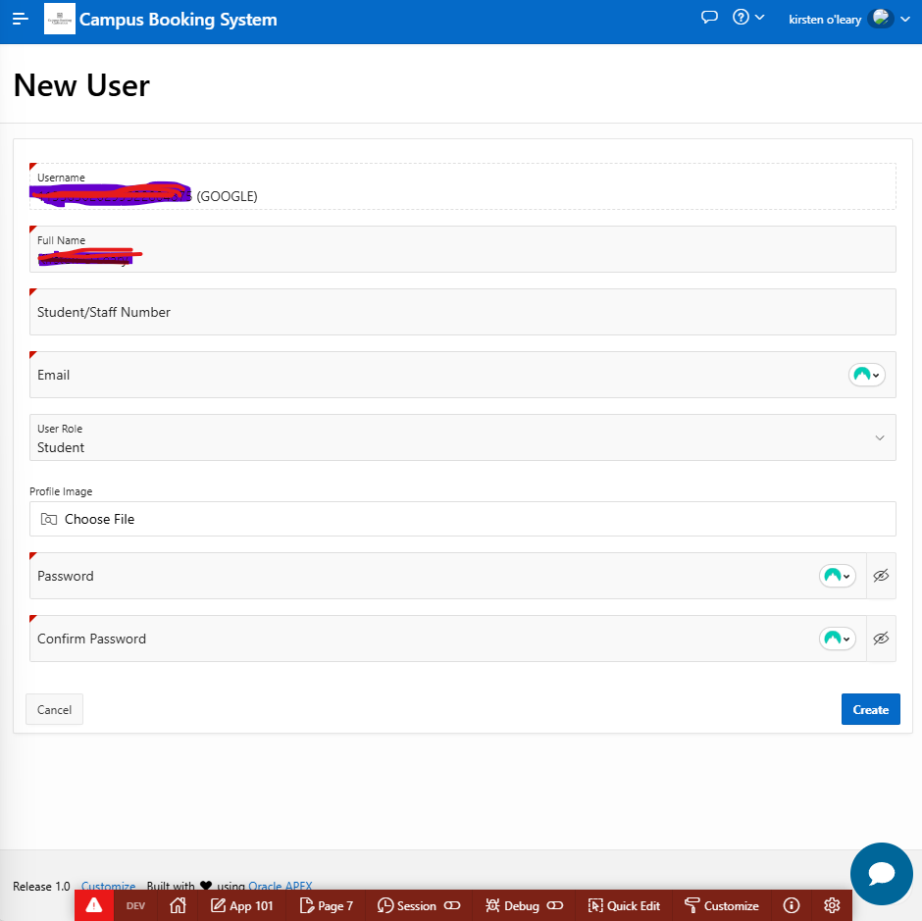
4 | 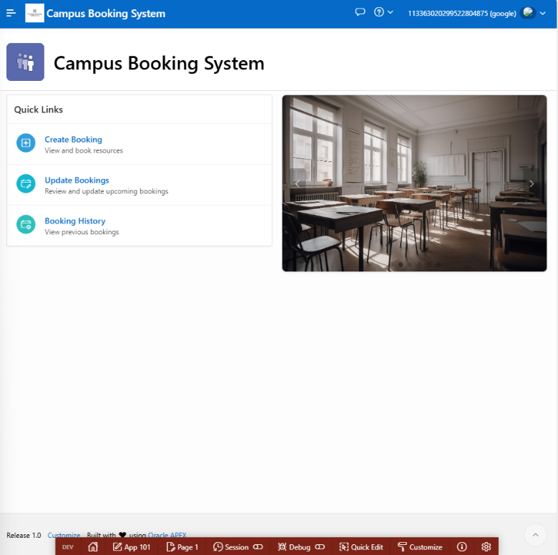  Once logged on you will be brought to the campus booking system home page
5 | 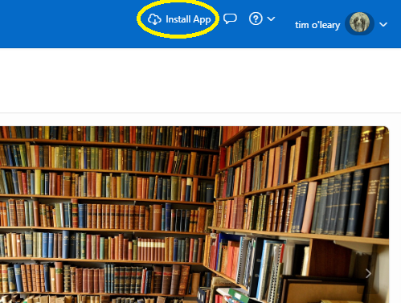  To install the application on your device click the Install App icon circled in yellow
6 | Where users experience difficulties with accessing the application please contact the administrator at x23287021@student.ncirl.ie.

Navigating the campus booking system application
Once the user has logged into the application successfully, the following functions are available.
Functionality | Location
Navigation Bar | This is located across the top of the screen and contains the following:  - Hamburger menu  - Application name – Campus Booking System  - Feedback form  - Help and about the application  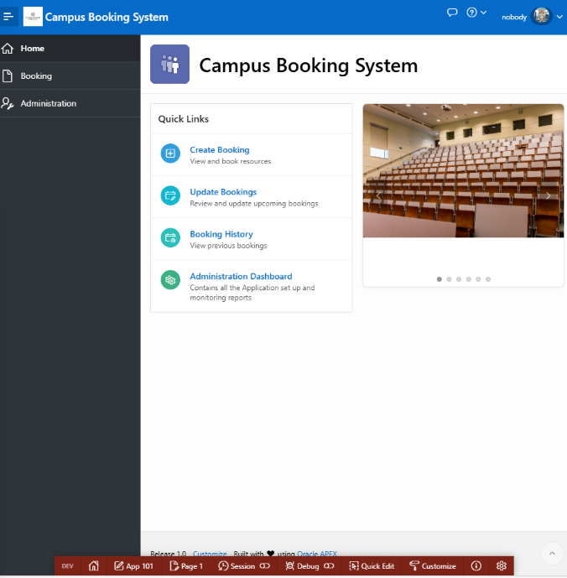  - User profile  The navigation bar is available on all pages to allow users to easily navigate the application.
Hamburger menu | This menu is available by clicking on the three horizontal bars on the top left-hand side of the home page. Once clicked a navigation menu will become available with the following options:  - Home  - Booking  - Administration (for administration users only)
Home page | The home page has the following quick links which can be selected by clicking on the required link:  - Create Booking: View and book resources  - Update Bookings: Review and update upcoming bookings  - Booking History: View previous bookings  - Administration Dashboard: contains application set up and monitoring reports (for administration users only)
Providing feedback | Feedback, including logging any issues, can be provided by clicking the speech bubble (marked with the yellow circle) on the navigation pain.  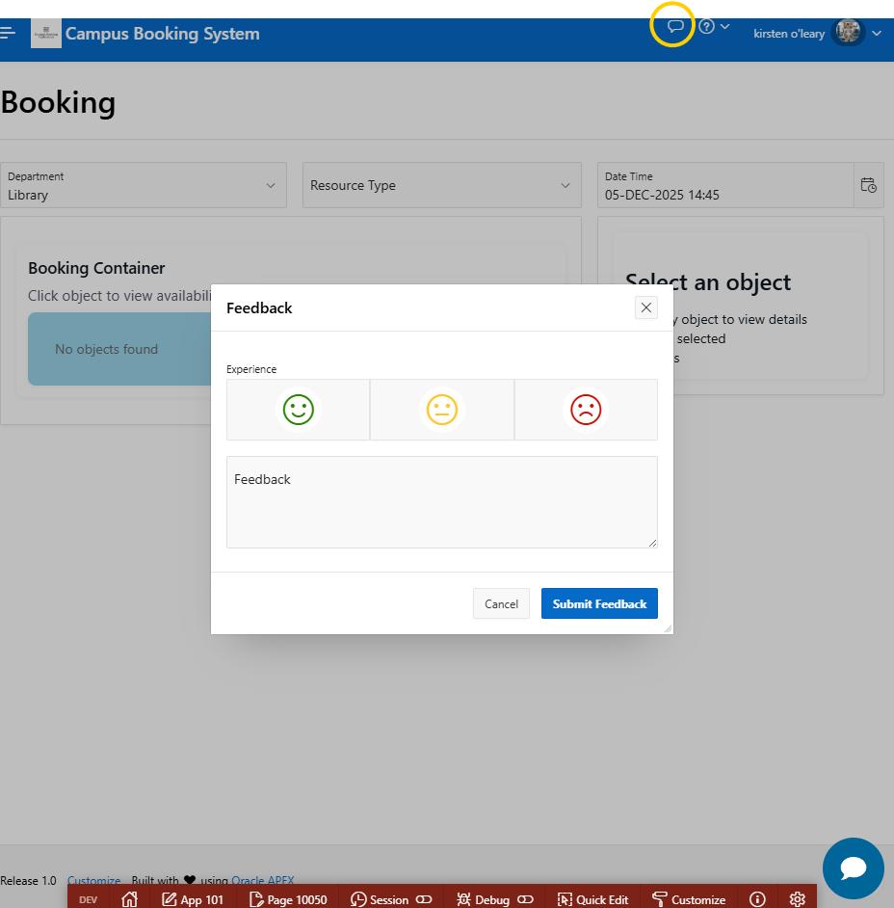  Users should provide as much details as possible and click the submit feedback button.
Page help and about the application | Additional information, including help is available by clicking the question mark icon, where help for the application and information about the application are available.  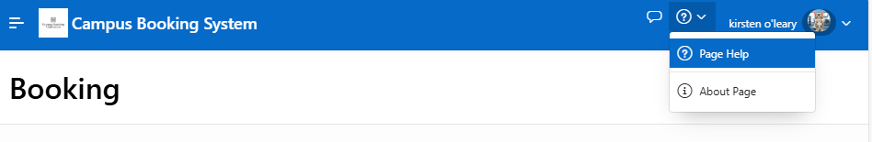
A.I. chatbot | 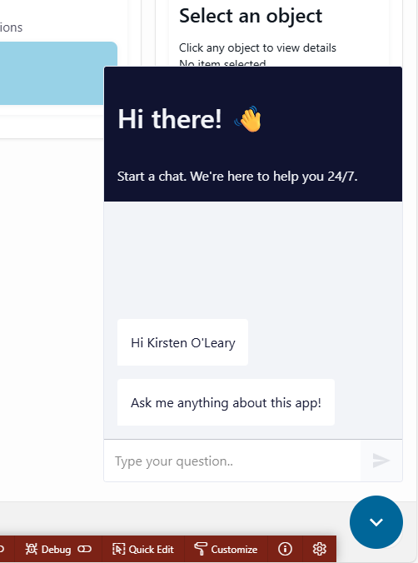  The A.I. chatbot is available to assist users. It is accessible by clicking the blue dot in the bottom right hand corner of the screen.  It can provide help to the user, such as answering questions or listing available resources to book.  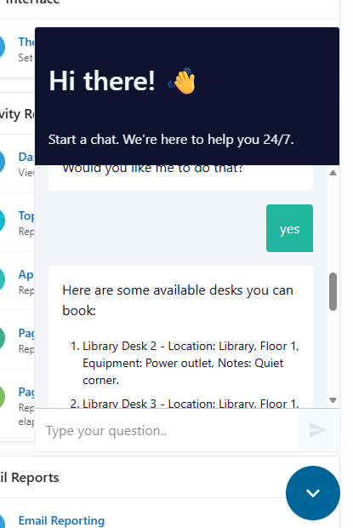

Create booking
This function is available to all users to view and book resources.
Functionality | Location
1 | From the home page, click on create booking from quick links.  Create booking can also be accessed by clicking booking on the navigation menu which will bring the user to the booking homepage where create booking can also be selected.  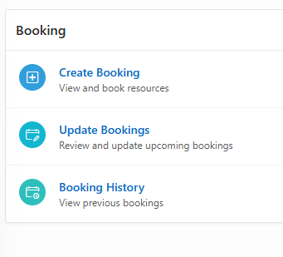
2 | On the create booking page, users should select the select the department in which the resource booking is required from the list available:  - Computer science dept  - Engineering dept  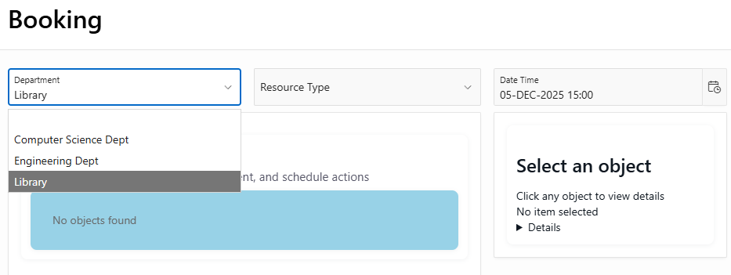  - Library
3 | Users should then select the resource type:  - Desk  - Equipment  - Lecture Hall (available for staff only)  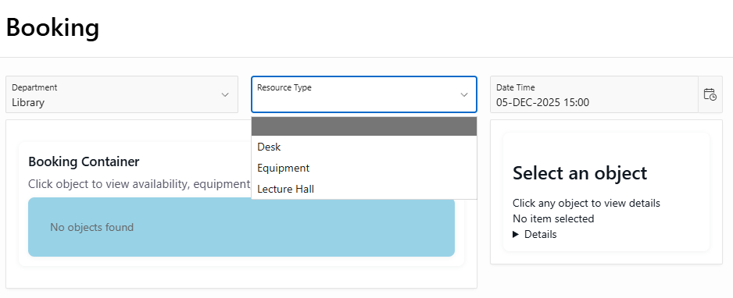
4 | The user should select the date and time that they require the booking for using the date time option  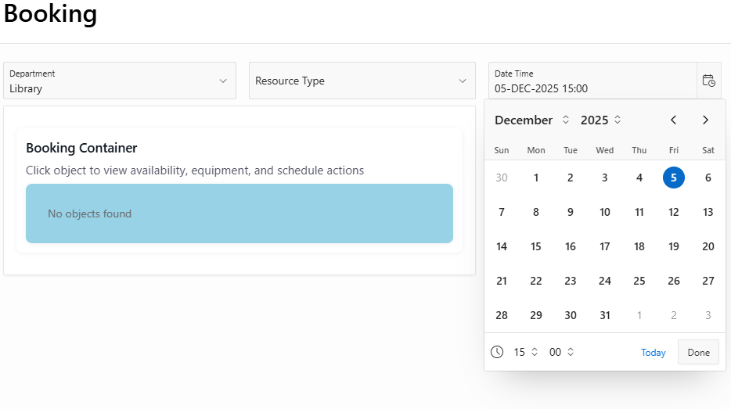
5 | Select the resource required from the available options and click schedule.  Note:  - Unavailable resources are greyed out.  - Information about the resource is provided on the right-hand side of the screen, for example, location, status and equipment plus any useful information such as quite area, central area etc.  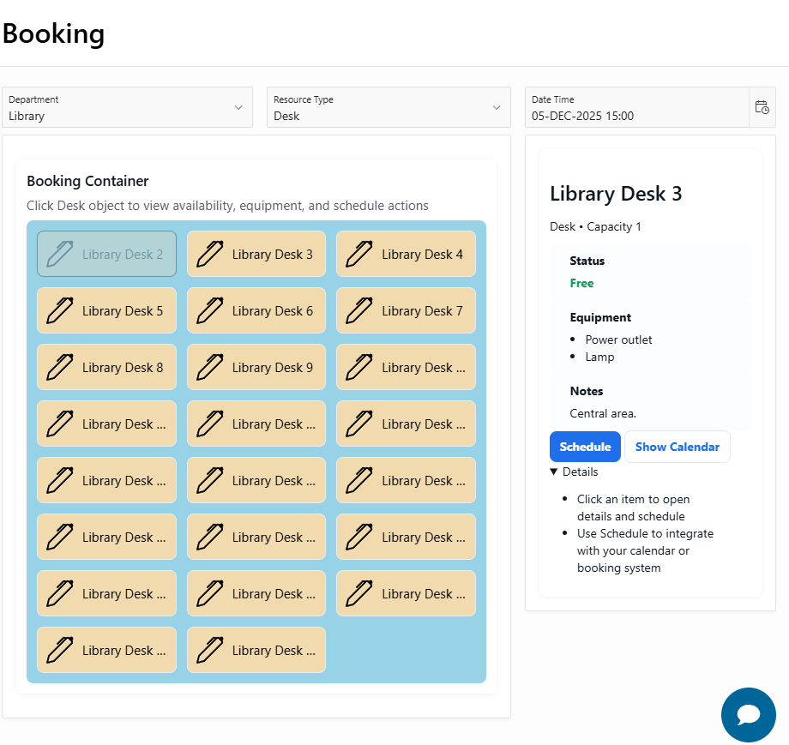
6 | 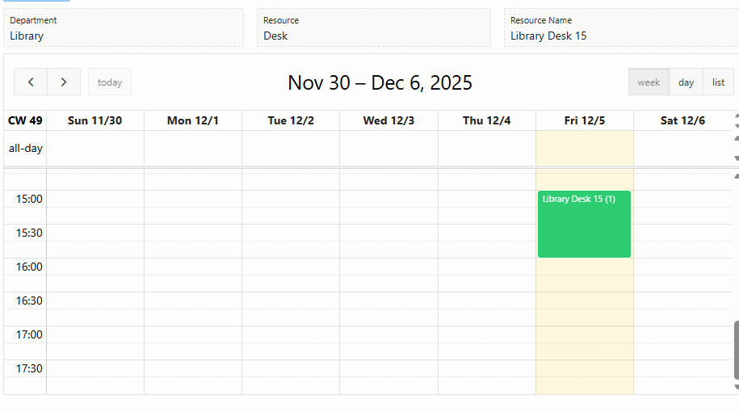  If users wish to view current bookings for the resource before creating a booking click the show calendar button.
7 | Add in the date and time on the create booking form and select create  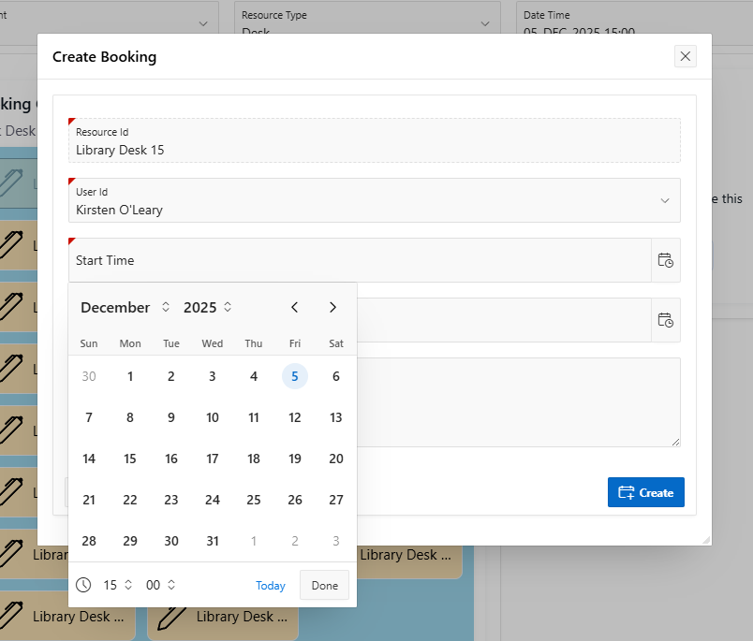
8 | Once the booking has been created, there is an option to apply any changes or send an invite to another person if required.  To exit click cancel or the x at the top of the screen.  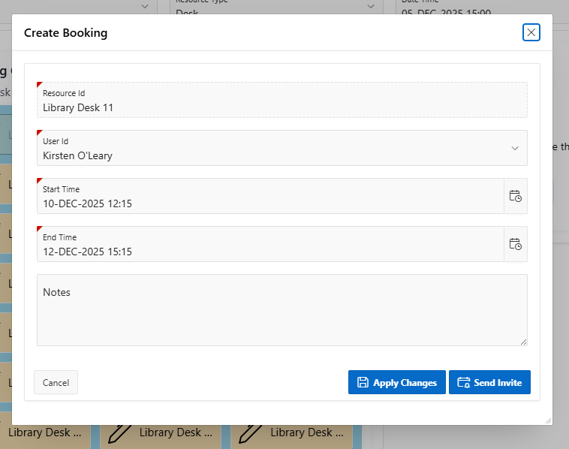  Note: If there is a booking conflict the application will not let the user book the desk and will advise that the resource is already booked in that time range.
9 | You can invite other users to the booking if the resource has a capacity greater than one, on creation an attendee’s sections will appear, select the required user and click send invite. Thie will send and email and a push notification if he user has enabled push notification on their device.  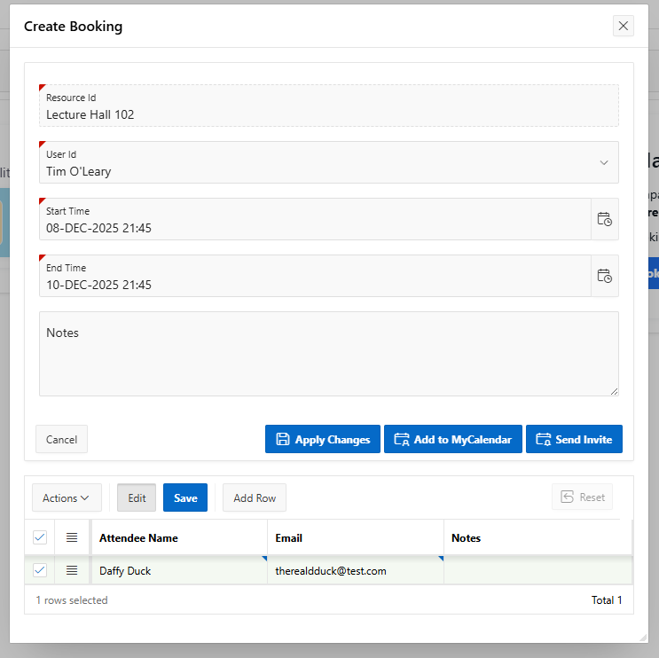
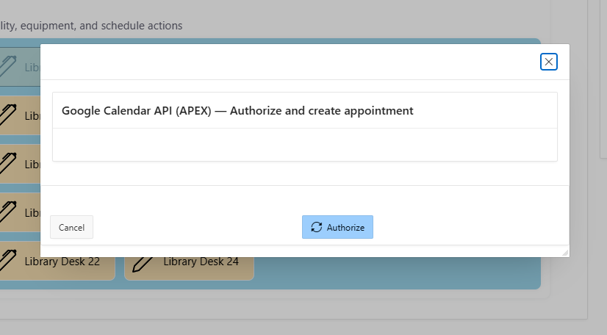
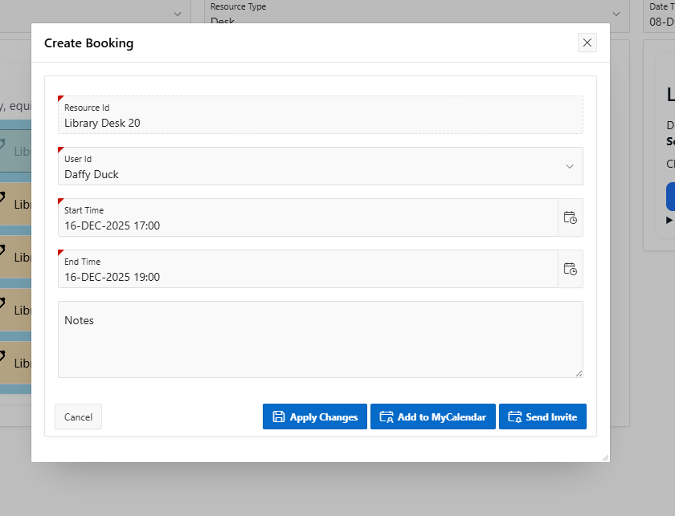
To send the invitation to your calander, click add to myCalander
- Click authorize to link your calander with the application.
- If a warning pops up please click Advanced and select the link to go to the page.
- Once verifided click create appointment.
10 | Staff only:  When booking a lecture hall, attendees can be added to the booking by click add row and selecting the required attendees.  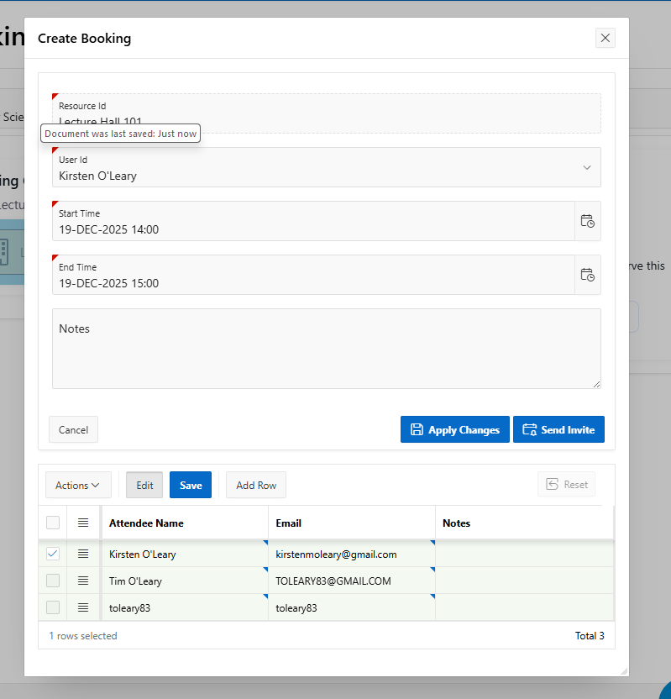

Update bookings
This option is used to update existing bookings.
Step | Instructions
1 | Click update bookings on the bookings page or on the quick links option of the home page.
2 | Upcoming bookings will display. To update an existing booking click on the edit icon on the left-hand column.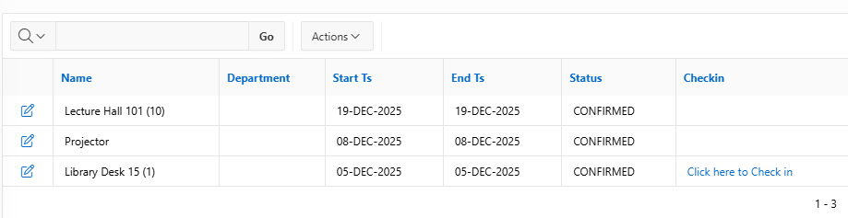
3 | 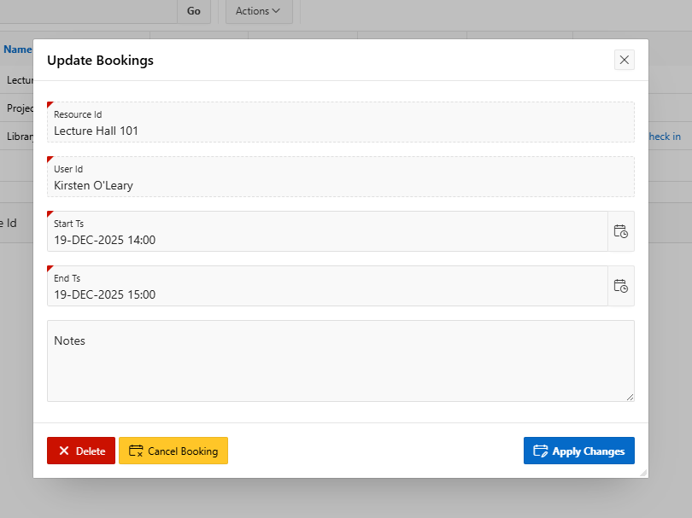  Edit booking as required or cancel booking using the Cancel Booking button.
4 | Users can also use this page to check into their resource by clicking the check in option to mark the resource as in use.  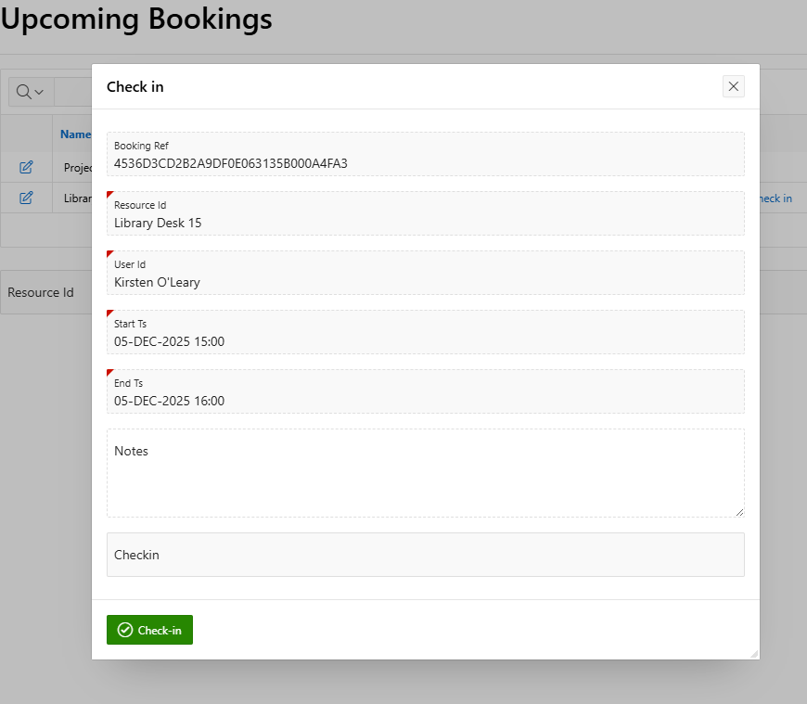

Previous bookings
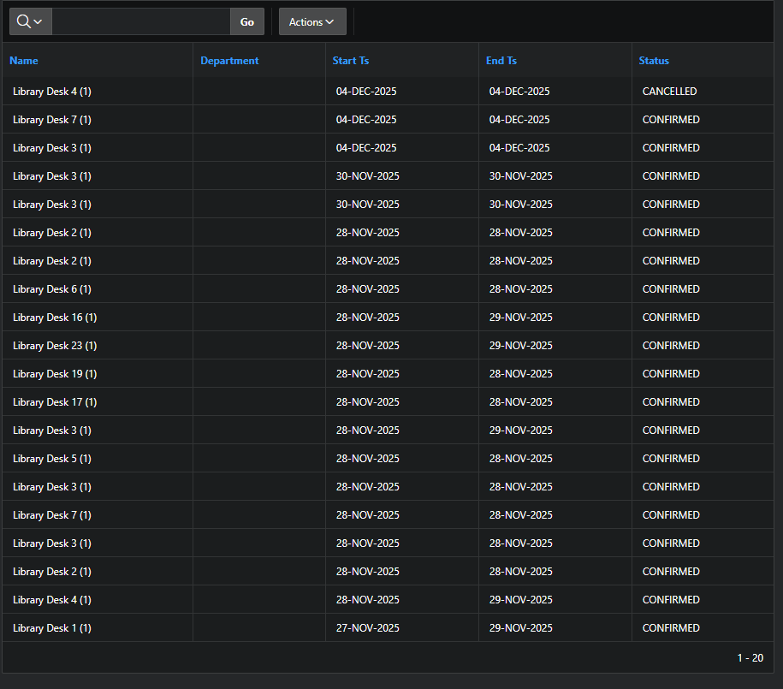
To view previous bookings, users should click the booking history option on the booking home page or the application home page quick links.

User profile
This option allows users to customise their application.
Step | Instructions
1 | Click on the user icon on the right-hand corner of the navigation bar  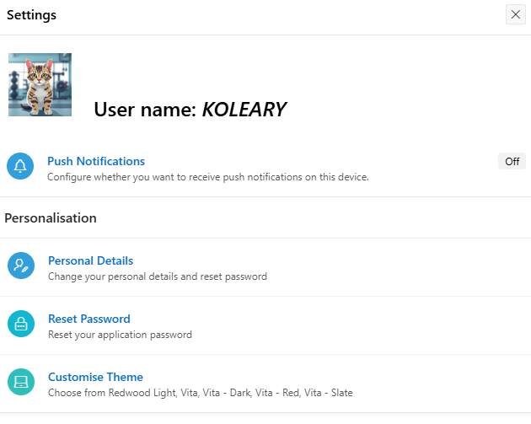
2 | Click on the option you wish to change
3 | To update push notifications, toggle the setting to on. 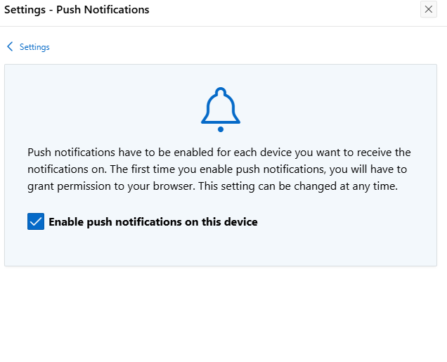  To turn push notification off, toggle the setting to off and unclick the enable push notifications option.
4 | 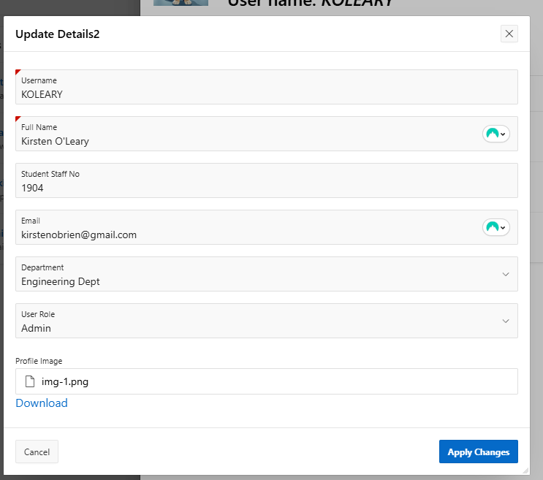  To update personal details, select this option update as required.
5 | 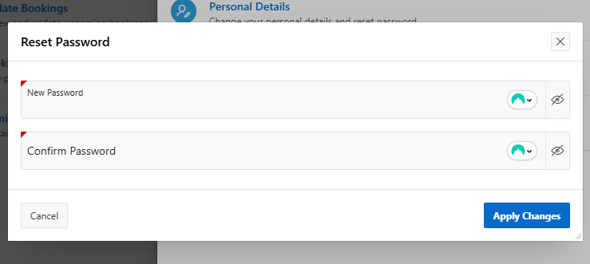  Reset password: select this option to reset your password.
6 | Customise your theme: to change the colour scheme select the preferred option and click apply changes.  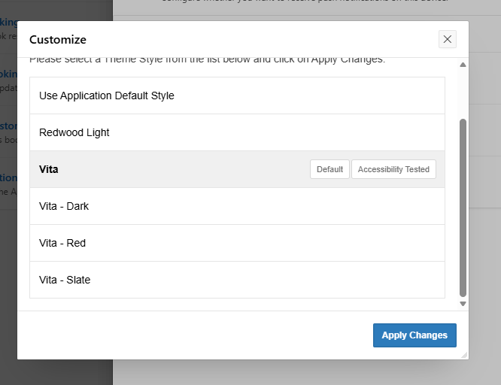

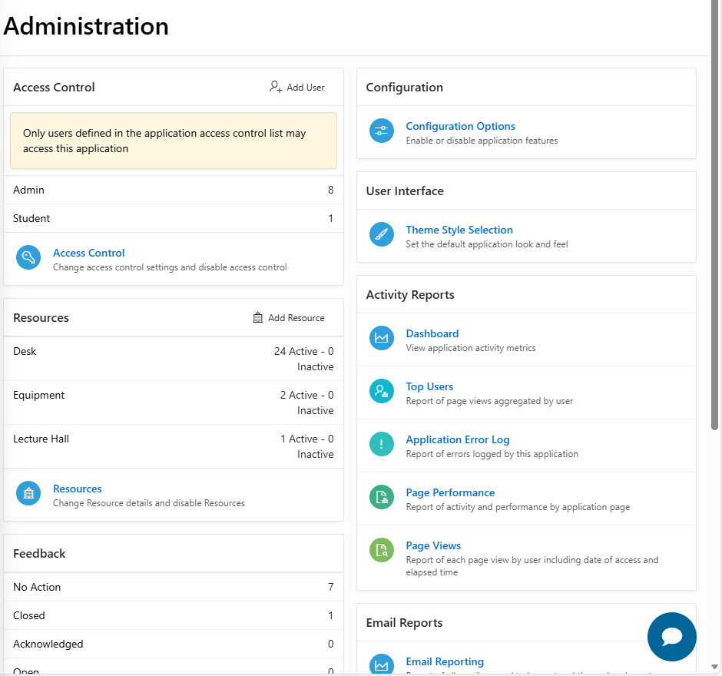
Administration home page
This homepage is available for administration users only.

Function | Information
Access Control – new user | 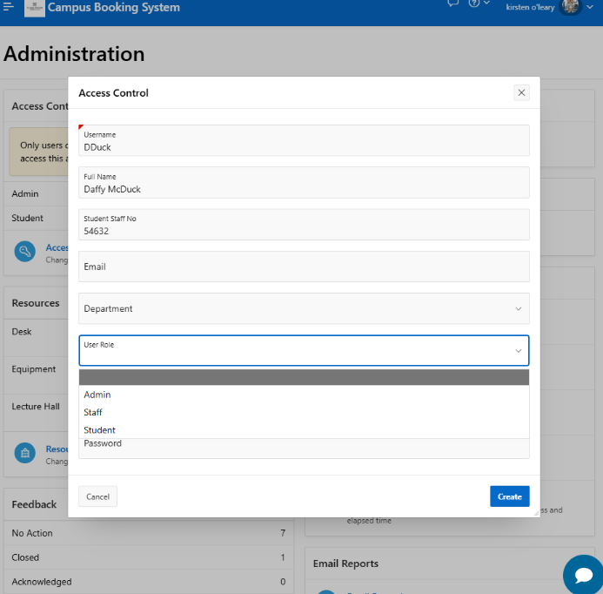  Click on the add user button to add a new user and complete the form.
Access control – manage existing users | Click on the access control button to open a list of all users.  - To edit users click on the edit button.  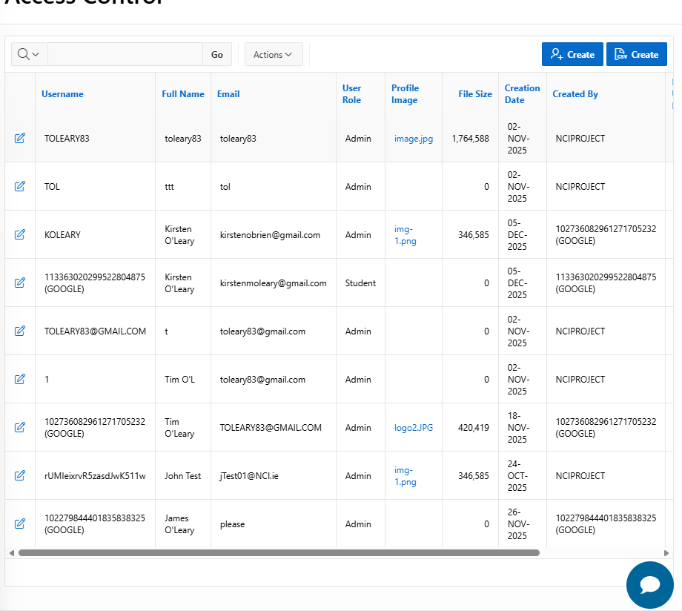  - To create a new user individual click on the create button.
Access control – bulk upload users | To bulk upload users, in the access control page, click on csv create and upload the required file. The file should be in csv format and use the appropriate template as follows:  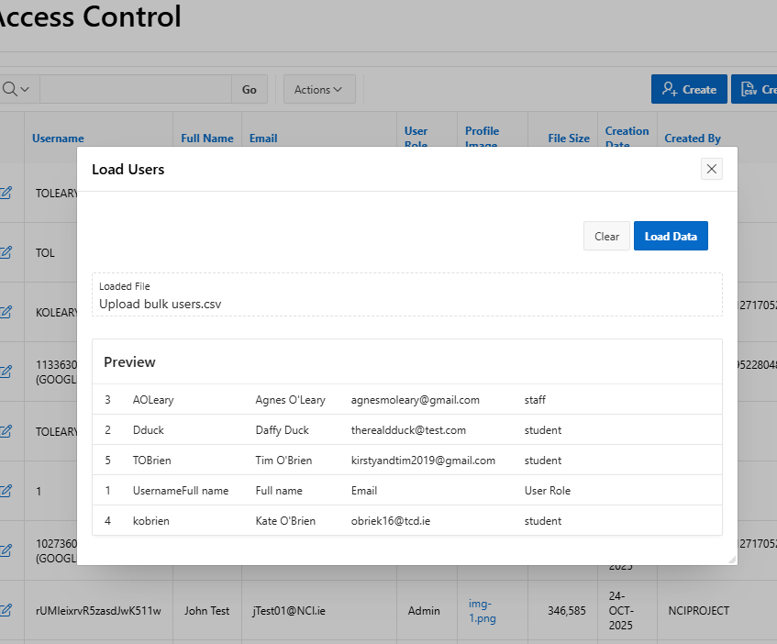
  USERNAME | FULL_NAME | EMAIL | USER_ROLE | PASSWORD | STUDENT_STAFF_NO | DEPARTMENT
  Dduck | Daffy Duck | therealdduck@test.com | student | Test!23 | 1236 | Computer Science Dept
Resources – add resource | 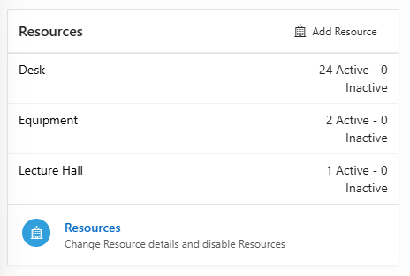  To add a new resource, click add resource.  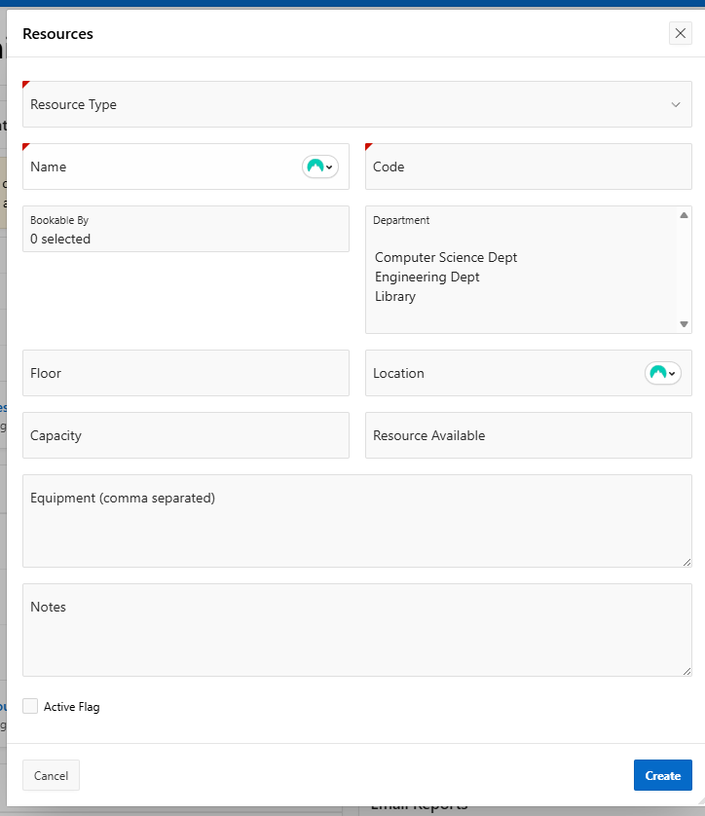  Complete the form that opens and click create.
Resources – manage resources | Click the resources icon.  - To edit existing resources click the edit button  - To create an individual resource click the create button  - To bulk upload resources click create csv and upload the csv file using the proper template  - To search use the search icon and filter as required.  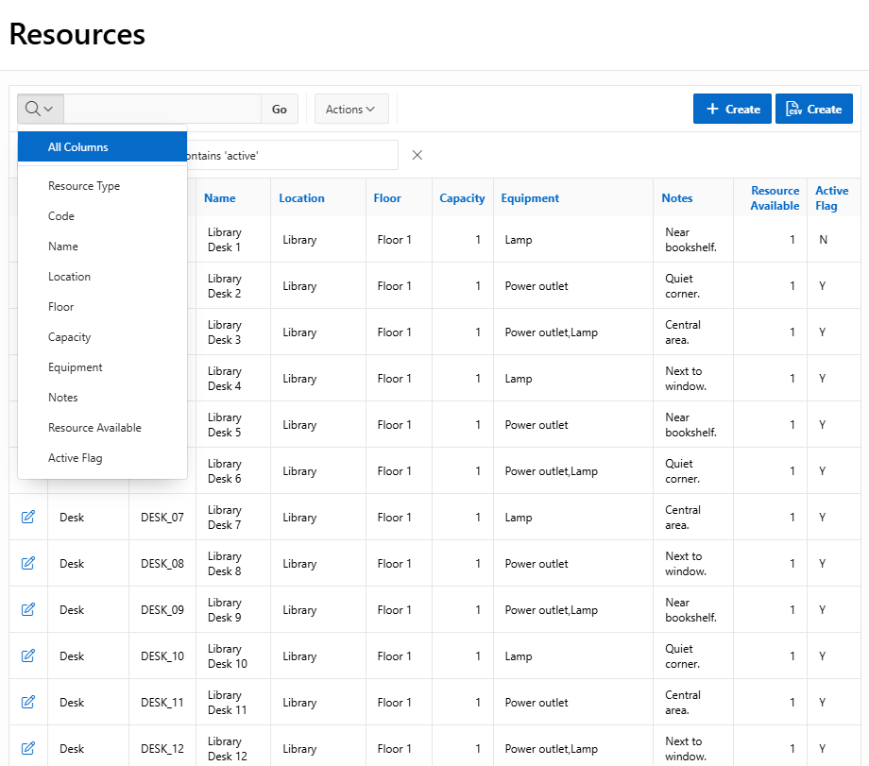
Feedback | 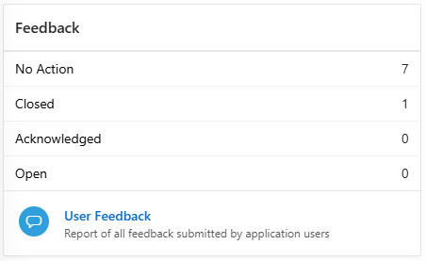  An overview of user feedback is available on the administration home page.  To view more details and individual user feedback select the user feedback option.
Booking | The administration page also contains links to the booking module of the application
Configuration Options | 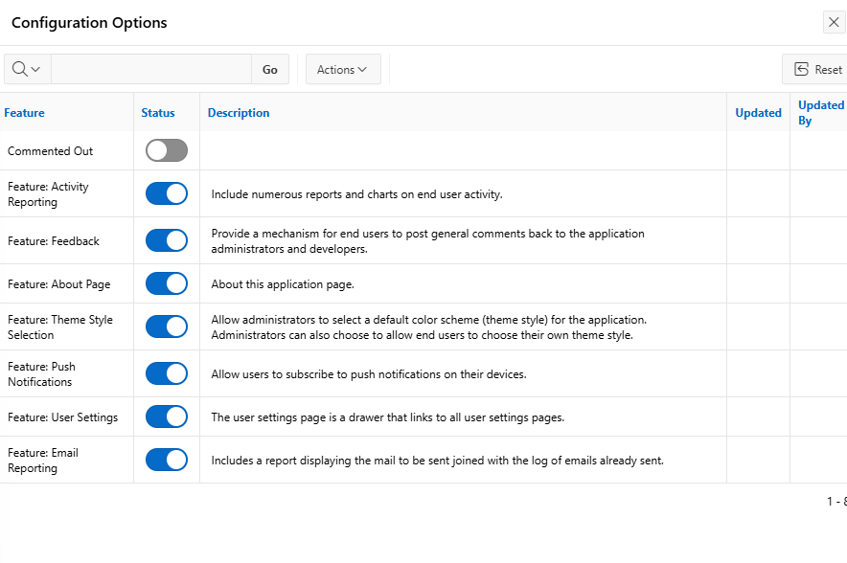  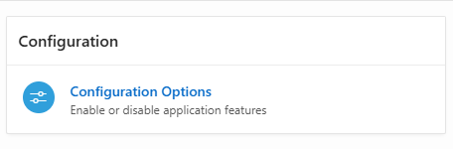  To configure settings in the application, select configuration options and toggle the status options on or off.
User Interface | 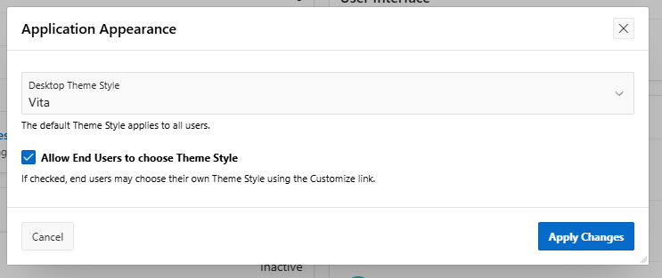  Select User Interface to change theme style selection settings. This setting allows the desktop theme default style to be changed and also allows users to choose their own style.
Activity reports | 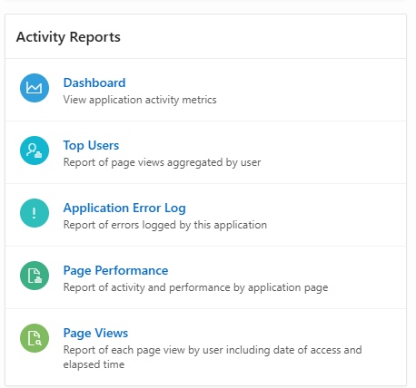  Select the activity report that you wish to view from the list available.
Email reports | This option provides a report of all emails queued to send. Where an error has occurred that will be recorded on this report.  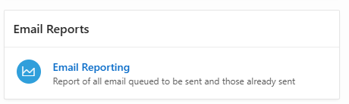
Push Reports | 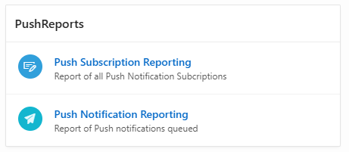  Select the preferred option to view push notification reports.

